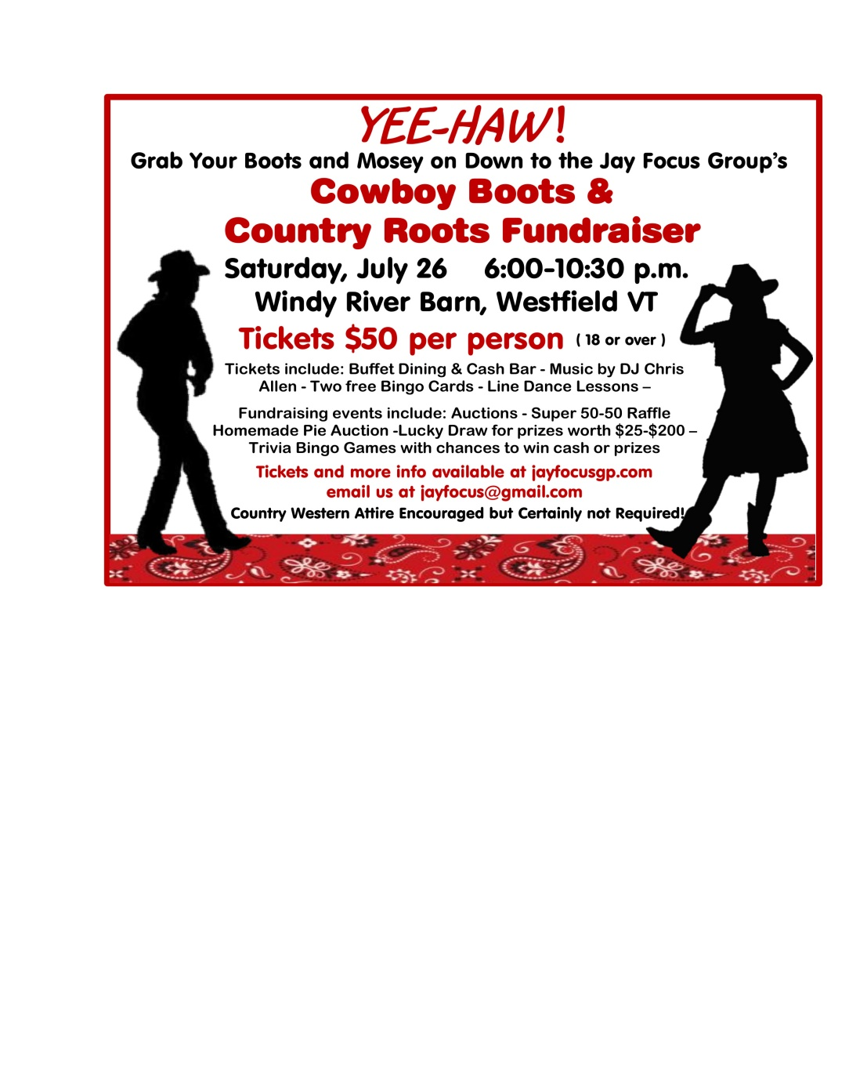**Greetings from the Jay Focus Group**

We are a 501©3 Non-Profit Organization helping people in need in Orleans County with Grants & Scholarships. Visit us at [www.jayfocusgp.com](http://www.jayfocusgp.com) to learn more about us and what we do.

This year we are holding a **Cowboy Boots & Country Roots Fundraiser** and hope you can help with a sponsorship, donation and/or attend the event.

Anything you can donate to help make this a successful fundraiser will be greatly appreciated.

**Choose one of three ways to Sponsor or Donate to the event by May 15:**

1. Fill out the attached form and return it with a check to: **Jay Focus Group PO Box 323, North Troy, VT 05859**

2. Online go to **jayfocusgp.com,** complete the form and pay using PayPal

3. Go to: **Venmo** and send payment to: @jayfocusgp

Please fill out the form below and return it by **May 15** to: **Jay Focus Group PO Box 323, North Troy, VT 05859**

**I would like to become an official sponsor of the Jay Focus Group’s Cowboy Boots & Country Fundraiser in the following capacity:**

Event Sponsor (Please circle one)

Donations of $500 may request 2 free tickets to the event

Gold Star Sponsor $500

Silver Star Sponsor $250

Brass Star Sponsor $150

Copper Star Sponsor (other amount) $__________________________________________________________________

I would like to donate a gift certificate or item described below to be used as a prize.

Value & Description of item:_________________________________________________________________________________

Please circle one: **Please Pick up donation I will mail donation**  **Donation enclosed**

I would like to purchase ________ tickets to event $50 pp ($500 sponsor may request 2 free tickets)

Name(s) on additional tickets________________________________________________________________________________________

**Contact Name____________________________________________________________________________________________________________**

**Organization / Business Name________________________________________________________________________________________**

**Mailing Address__________________________________________________________________________________________________________**

**Phone Number______________________________ Email Address: ________________________________________________**

**Website____________________________________________________________________________________________________________________**

If you have any questions: please call Peggy at 802-343-5687 or Email [jayfocusgp@gmail.com](mailto:jayfocusgp@gmail.com)

***Thank you for your generosity and your continued support***

***of our organization’s efforts to help those in need in Orleans County.***

**Our E.I.N# is 30-0559725**