
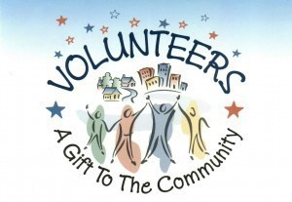
JAY FOCUS GROUP
Grant for Schools, Libraries & Non Profits
In Orleans County

The Jay Focus Group, a 501 (c) 3 Non-Profit Charitable Organization, offers a Grant of up $500 to
Orleans County Schools, Libraries and/or Non-Profits in a 12-month period.
Applications accepted starting Dec 1, 2023 thru Dec 1, 2024
Application Date |  | E.I.N Number
Applicant Name  (Must be administrator) |  | Position
Co-Applicant |  | Position
School/Non-Profit
Mailing Address
Email of Applicants: |  | Co- Applicant
Web Site url
Telephone of Applicant |  | Co- Applicant
Amount of
Request
Age range of those who will benefit from this funding
Describe how the funds will be used.
Feel free to include photos or additional documentation.

Applicants will be notified about grant approval/denial within 30 days of receipt of application.
Additional information about the award will be provided at that time.
Applicants must attach copy of their IRS-Non-Profit Determination Letter or an Approval Letter from School Principal
or Library Trustee as part of the grant application. Questions? jayfocusgp@gmail.com www.jayfocusgp.com
Mail Application to: Jay Focus Group, PO Box 323, North Troy, VT 05859 or email to jayfocusgp@gmail.com

